Oval Closed Shapes
# Source: AI Source: Provided by: [Data Path: Persons Table -> ID Column: 1, Name_En Column: Motasem Essam] -> From: [ChatGPT] on [7/25/2026]
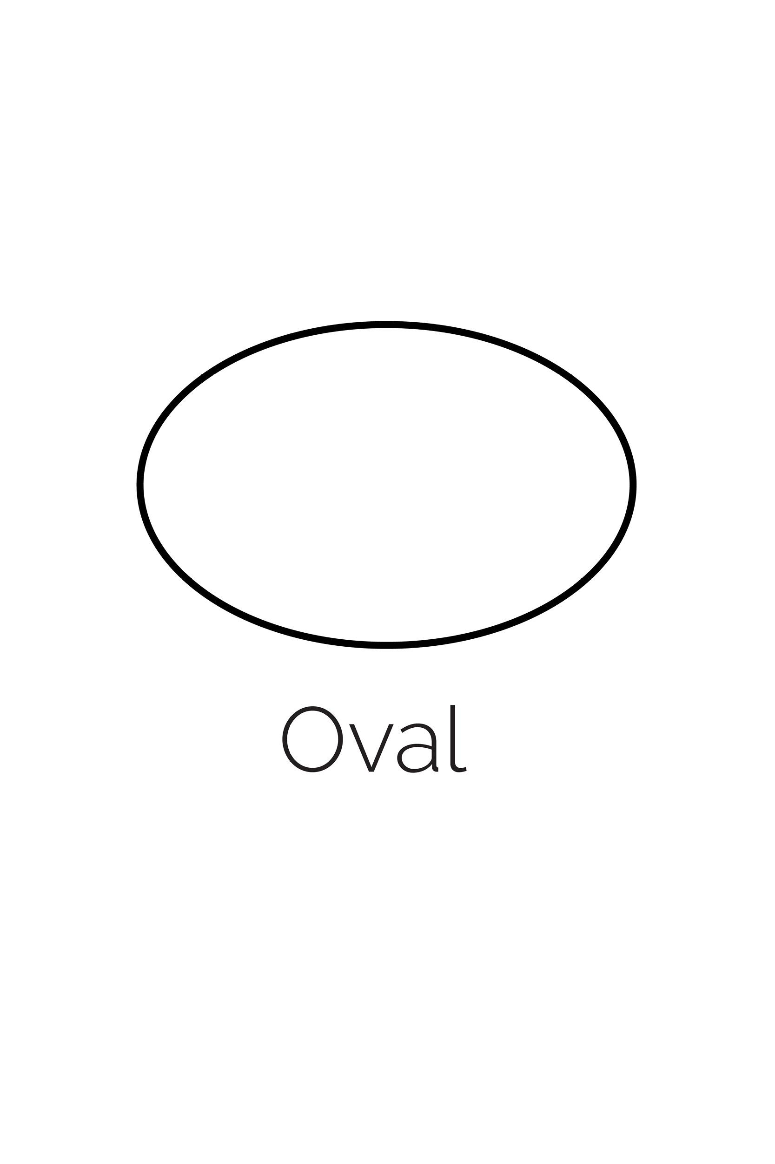
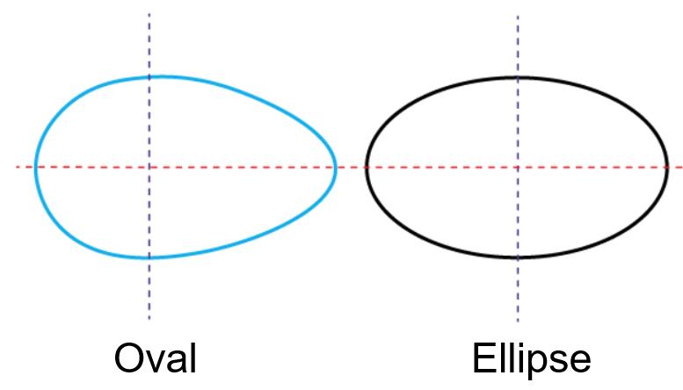
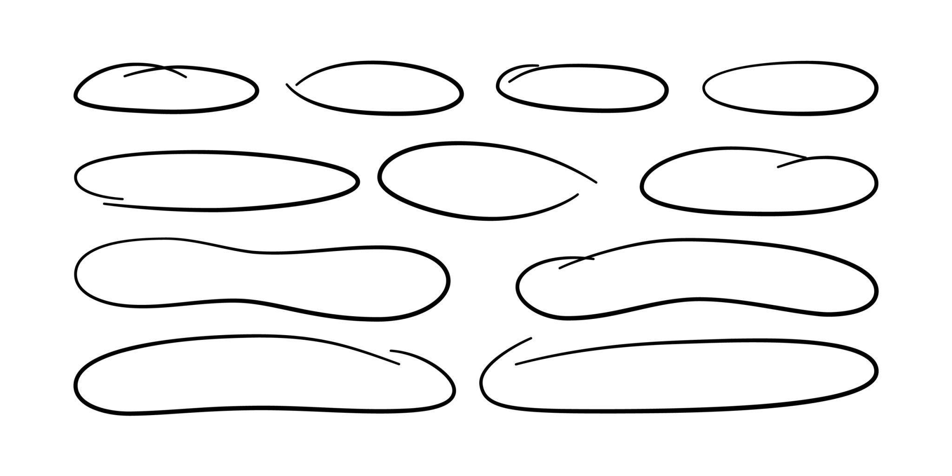
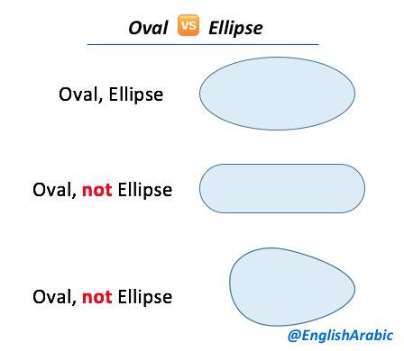
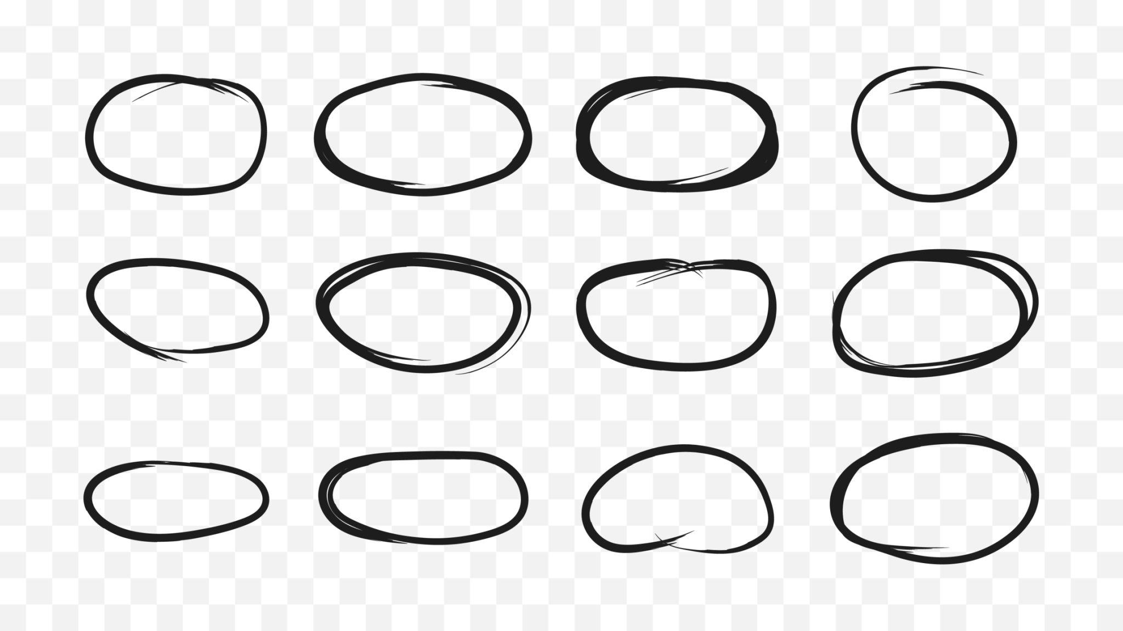
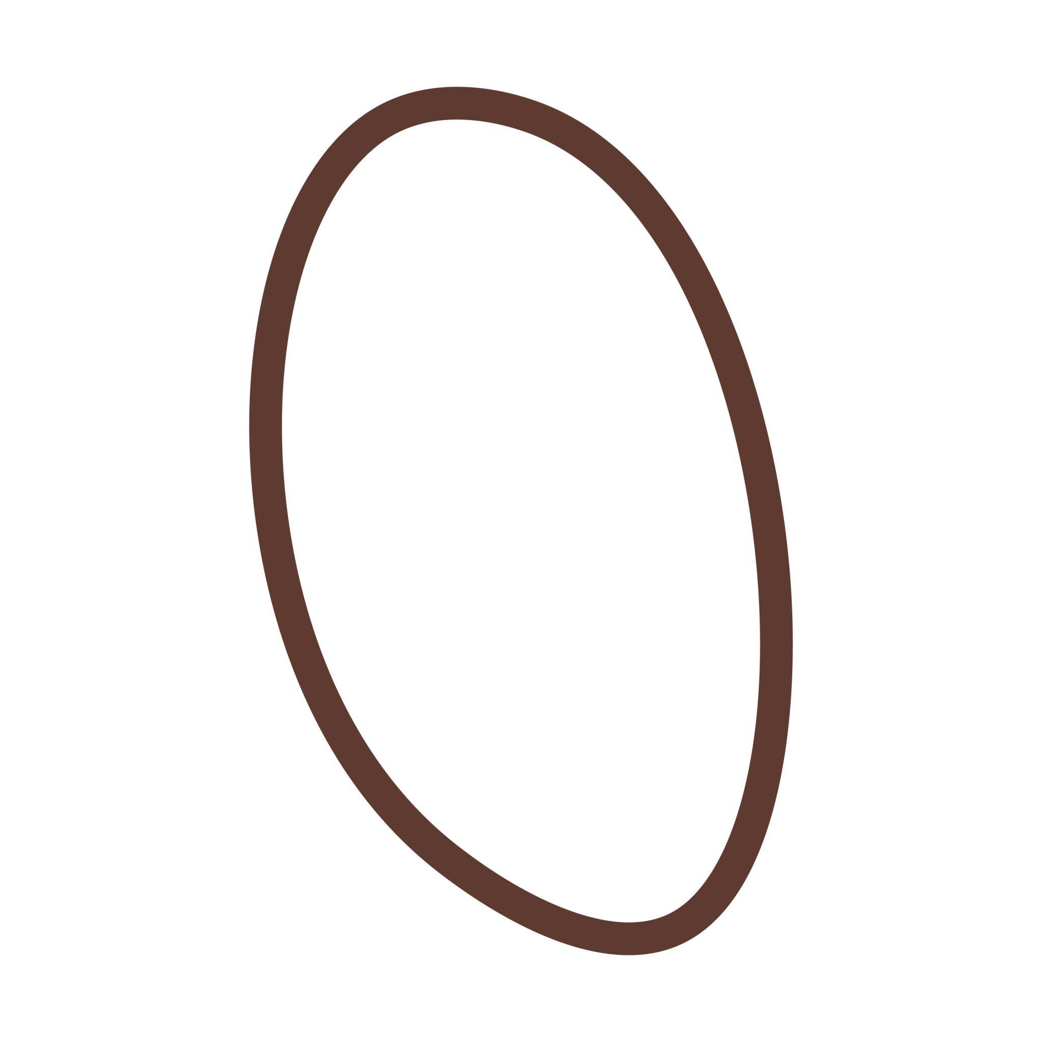

Definition
# Source: AI Source: Provided by: [Data Path: Persons Table -> ID Column: 1, Name_En Column: Motasem Essam] -> From: [ChatGPT] on [7/25/2026]
An Oval Closed Shape is a closed curved shape with a smooth, rounded boundary that is generally elongated or egg-like in appearance.
Unlike an ellipse, oval is primarily a descriptive geometric term rather than one single precise mathematical curve.
$$\boxed{\text{Oval Closed Shape}=\text{Closed}+\text{Smooth Curved Boundary}+\text{Rounded Elongated Form}}$$
An oval:
- Has no open endpoints.
- Has no straight sides in its pure form.
- Has no sharp vertices.
- Encloses a bounded region.
- Is usually longer in one direction than another.
- May or may not be mathematically elliptical.

Types of Oval Closed Shapes

1. Elliptical Oval
# Source: AI Source: Provided by: [Data Path: Persons Table -> ID Column: 1, Name_En Column: Motasem Essam] -> From: [ChatGPT] on [7/25/2026]
An elliptical oval is an oval whose boundary is an exact ellipse.
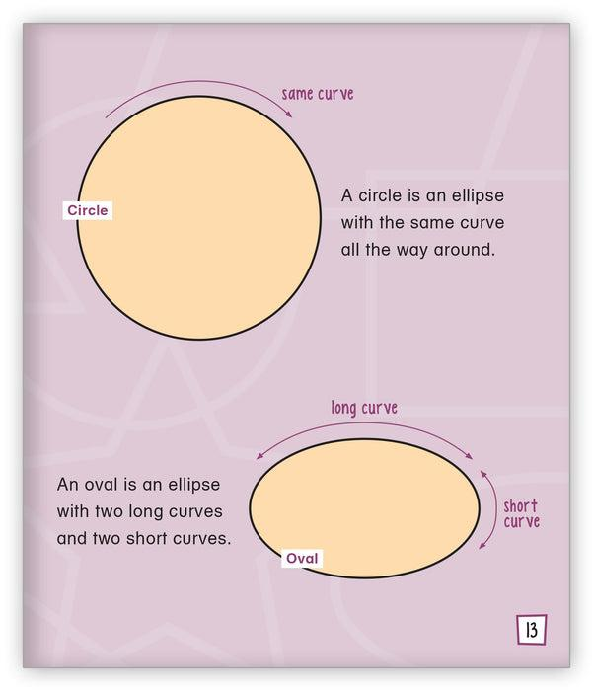
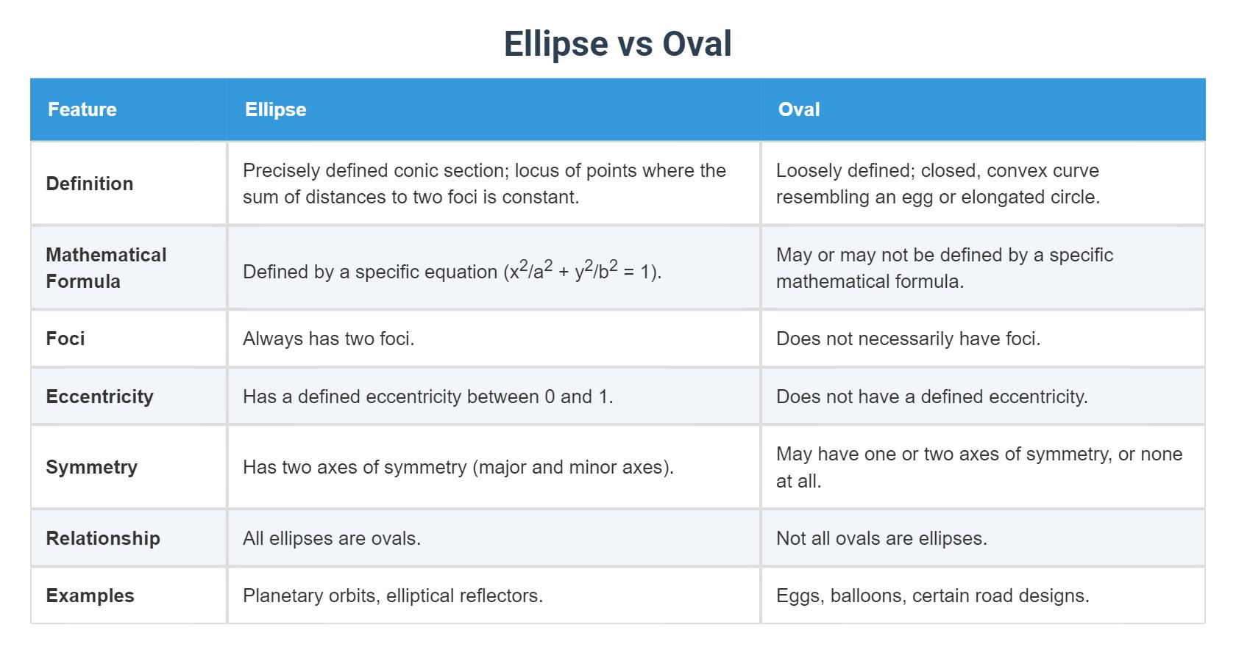
It can be represented by:
$$\boxed{\frac{{\left(x-h\right)}^{2}}{a^{2}}+\frac{{\left(y-k\right)}^{2}}{b^{2}}=1}$$
This is the most mathematically precise type of oval.

2. Elongated Oval
# Source: AI Source: Provided by: [Data Path: Persons Table -> ID Column: 1, Name_En Column: Motasem Essam] -> From: [ChatGPT] on [7/25/2026]
An elongated oval has a noticeably greater length than width.
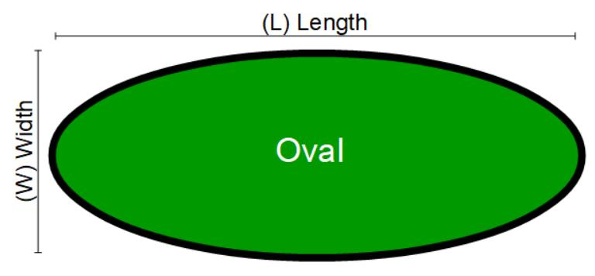
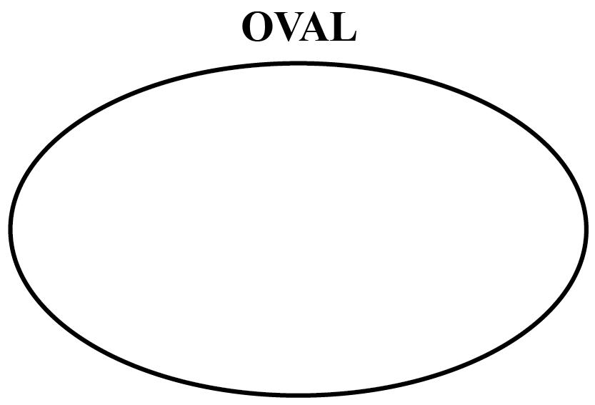
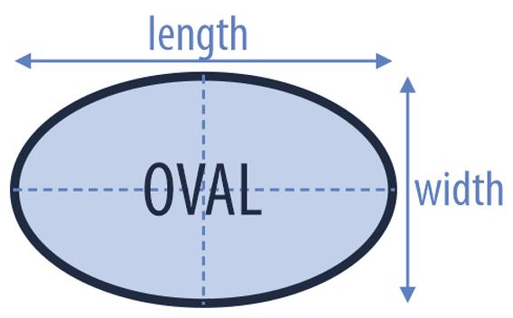
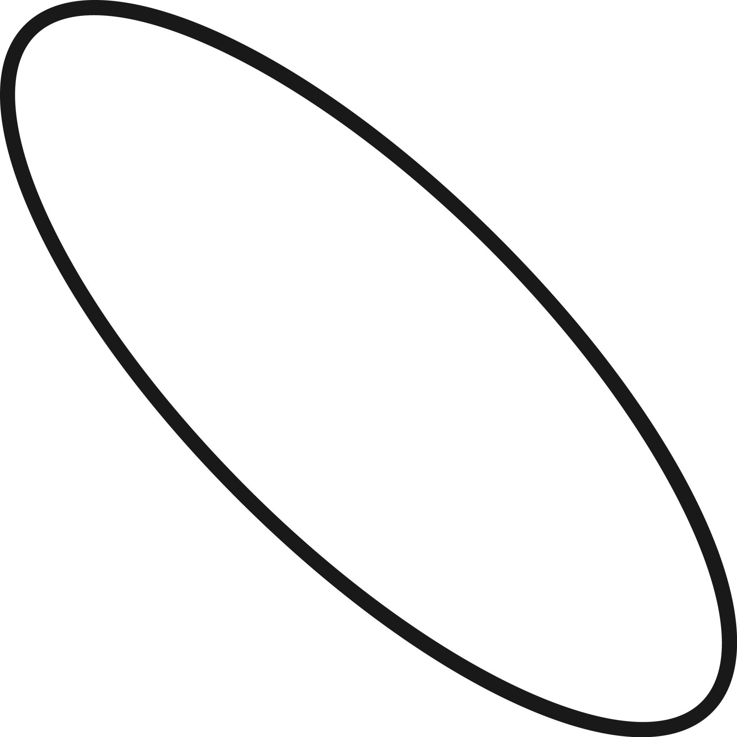
Its aspect ratio is relatively large:
$$\boxed{\frac{\text{Length}}{\text{Width}}>1}$$
The greater the ratio, the more elongated the oval appears.

3. Flattened Oval
# Source: AI Source: Provided by: [Data Path: Persons Table -> ID Column: 1, Name_En Column: Motasem Essam] -> From: [ChatGPT] on [7/25/2026]
A flattened oval is wider than it is tall and has a compressed appearance.
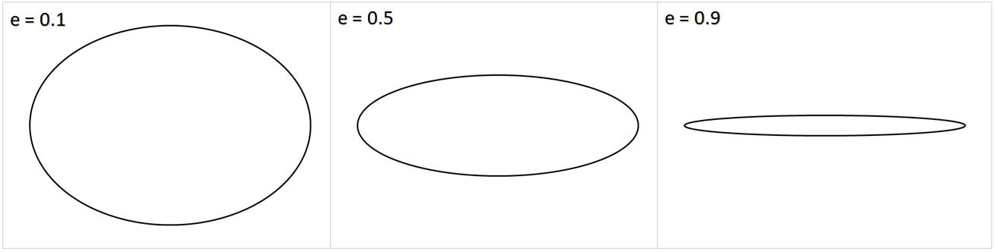
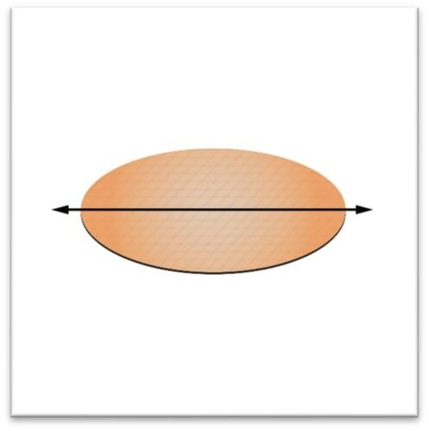
It can be viewed as a vertically compressed rounded form.

4. Vertical Oval
# Source: AI Source: Provided by: [Data Path: Persons Table -> ID Column: 1, Name_En Column: Motasem Essam] -> From: [ChatGPT] on [7/25/2026]
A vertical oval is elongated primarily in the vertical direction.
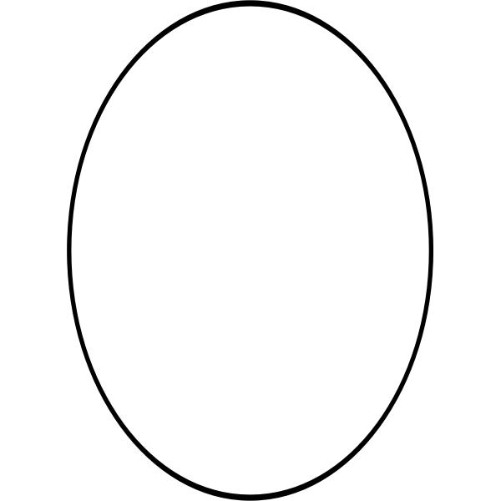
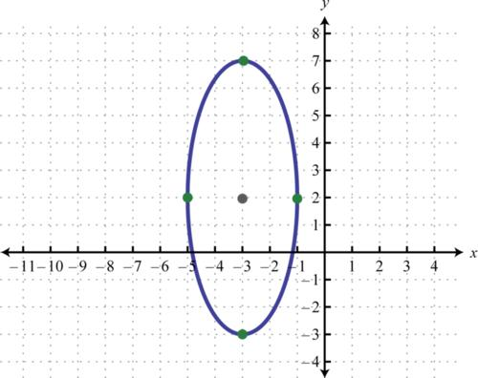
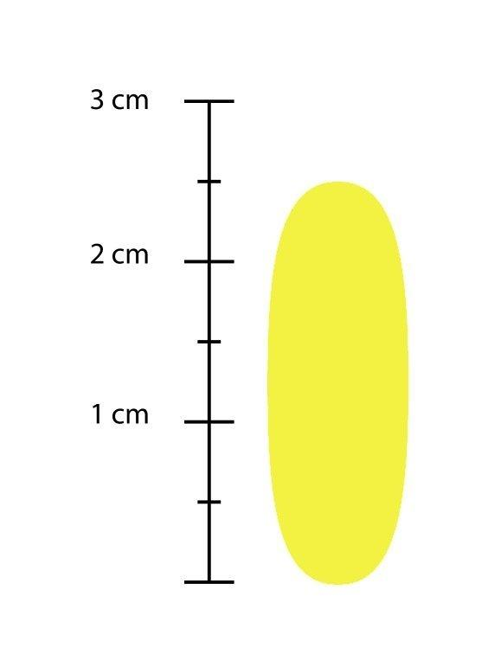
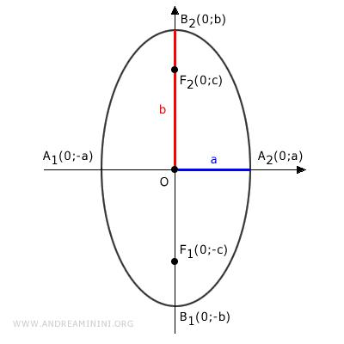
Its major dimension is approximately vertical.

5. Horizontal Oval
# Source: AI Source: Provided by: [Data Path: Persons Table -> ID Column: 1, Name_En Column: Motasem Essam] -> From: [ChatGPT] on [7/25/2026]
A horizontal oval is elongated primarily in the horizontal direction.
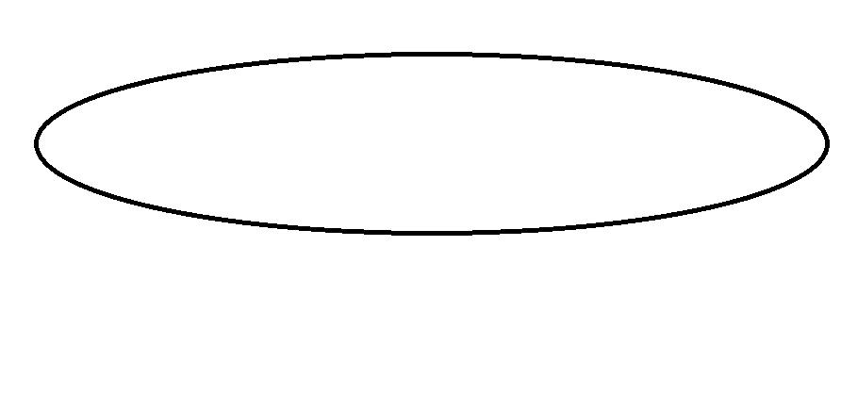
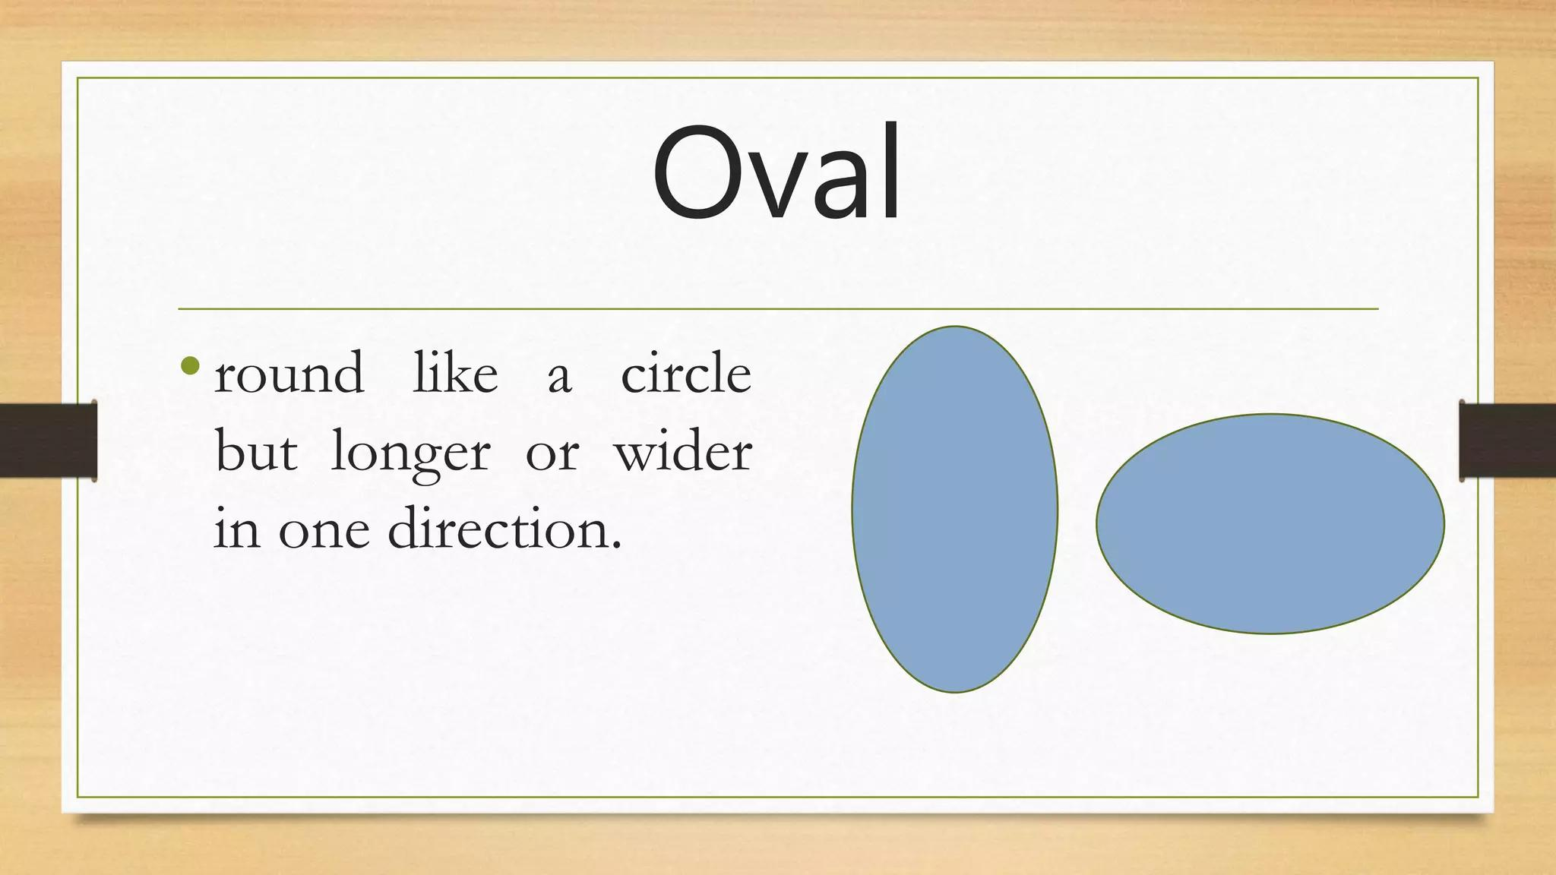
Its major dimension is approximately horizontal.

6. Egg-Shaped Oval
# Source: AI Source: Provided by: [Data Path: Persons Table -> ID Column: 1, Name_En Column: Motasem Essam] -> From: [ChatGPT] on [7/25/2026]
An egg-shaped oval has a rounded form that is wider toward one end and narrower toward the other.
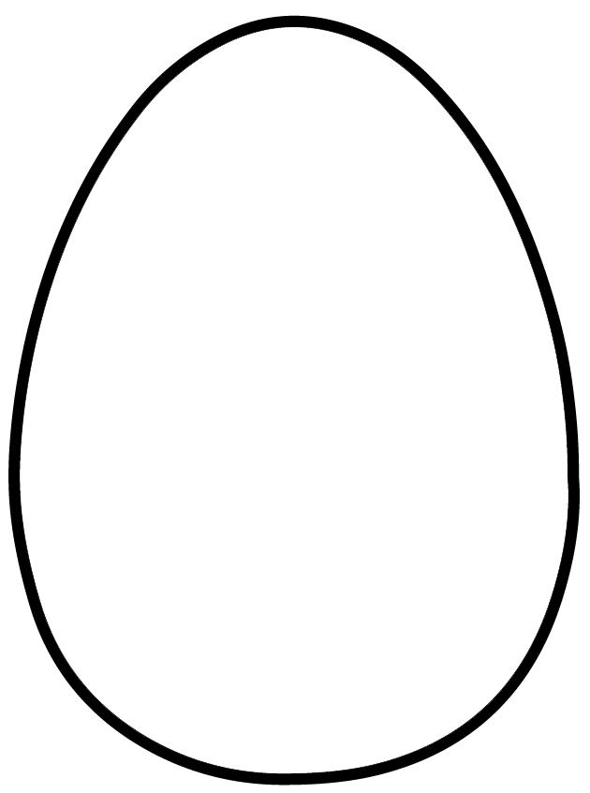
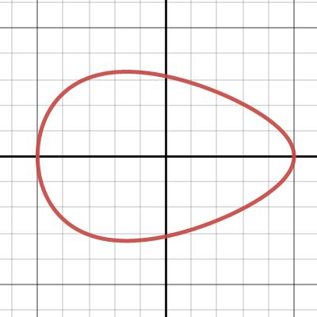
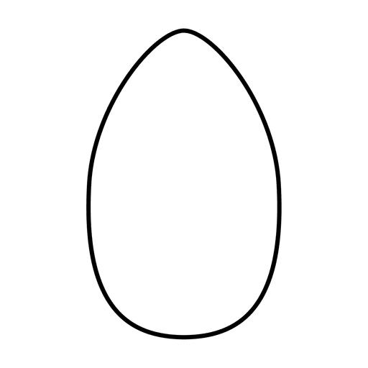
Unlike a standard ellipse, an egg-shaped oval is generally asymmetric about its horizontal axis.
It can therefore be classified as:
$$\boxed{\text{Irregular Oval}}$$
when the two ends are not geometrically equivalent.

7. Symmetric Oval
# Source: AI Source: Provided by: [Data Path: Persons Table -> ID Column: 1, Name_En Column: Motasem Essam] -> From: [ChatGPT] on [7/25/2026]
A symmetric oval has a balanced shape around one or more axes.
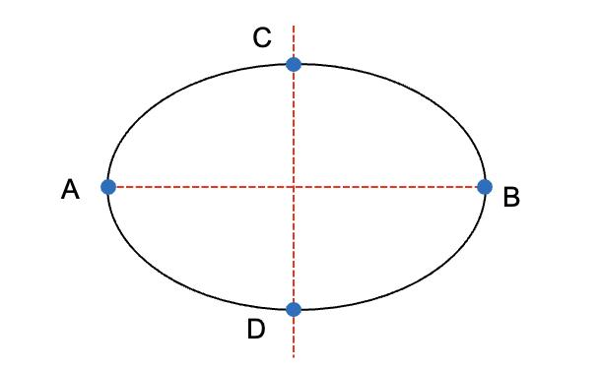
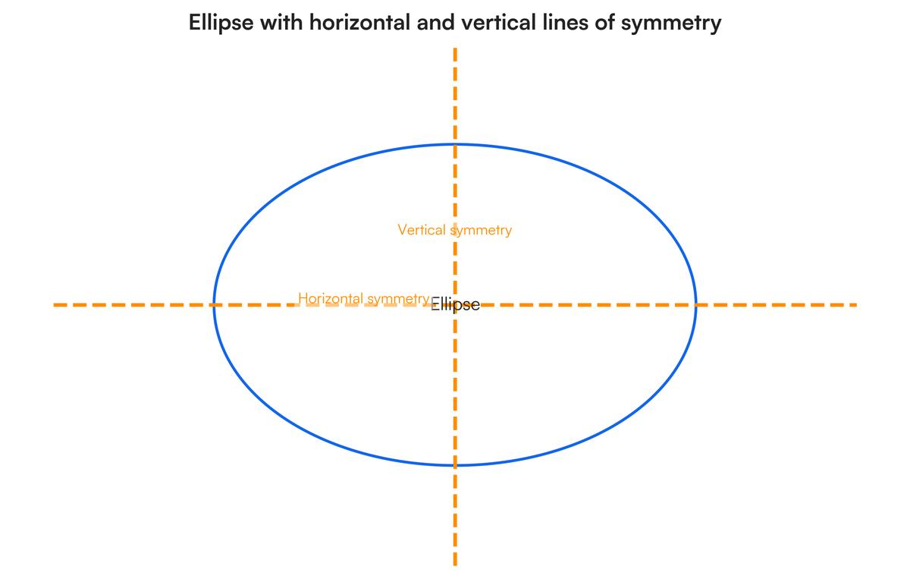
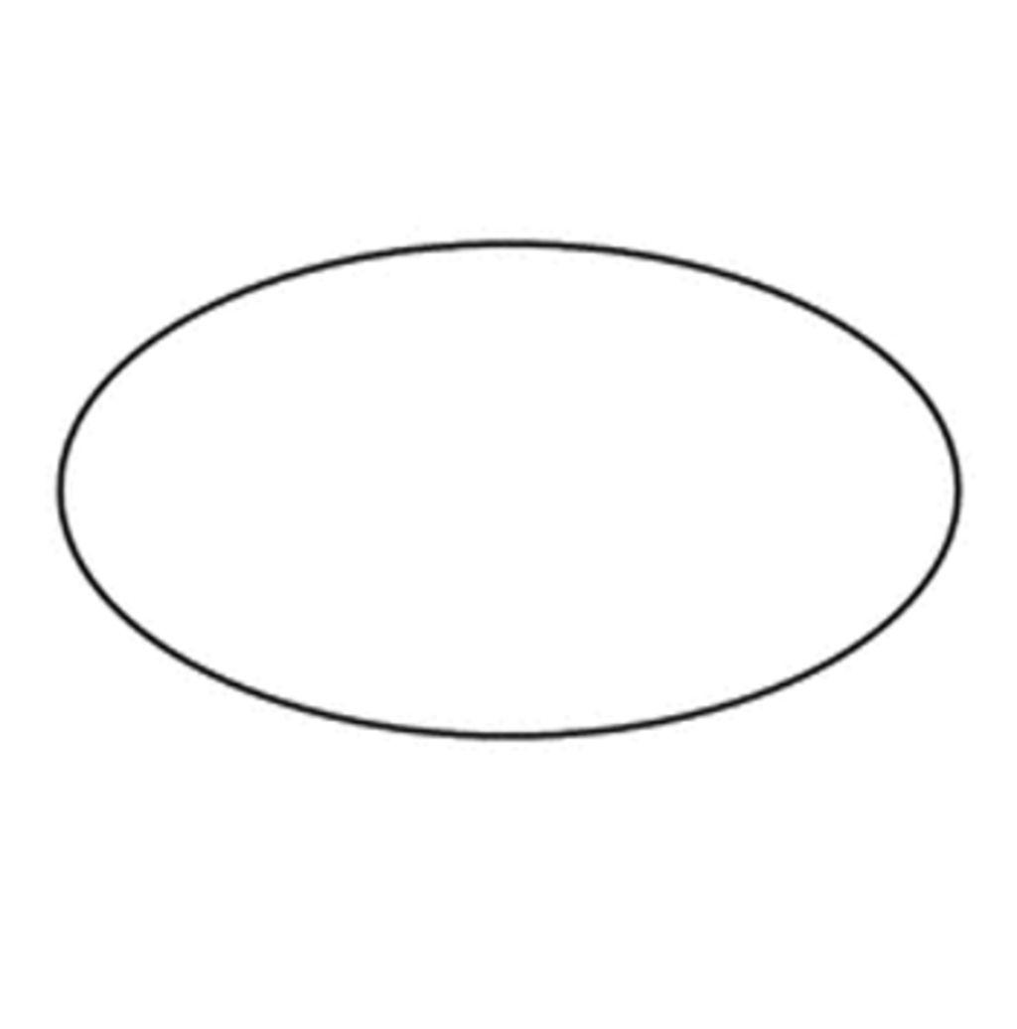
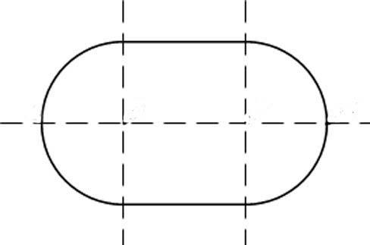
A typical elliptical oval has:
- Horizontal symmetry.
- Vertical symmetry.
- ${180}^{∘}$ rotational symmetry.

8. Asymmetric Oval
# Source: AI Source: Provided by: [Data Path: Persons Table -> ID Column: 1, Name_En Column: Motasem Essam] -> From: [ChatGPT] on [7/25/2026]
An asymmetric oval does not have a regular axis of symmetry.
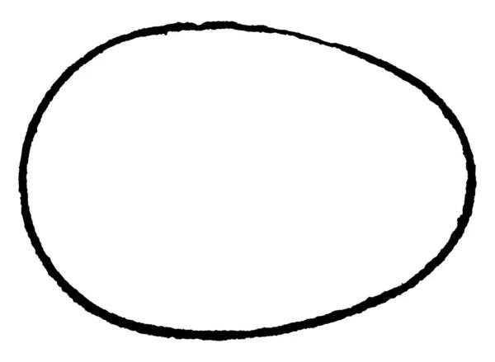
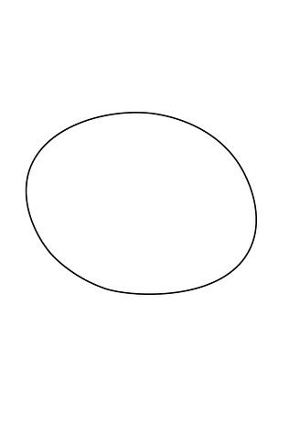
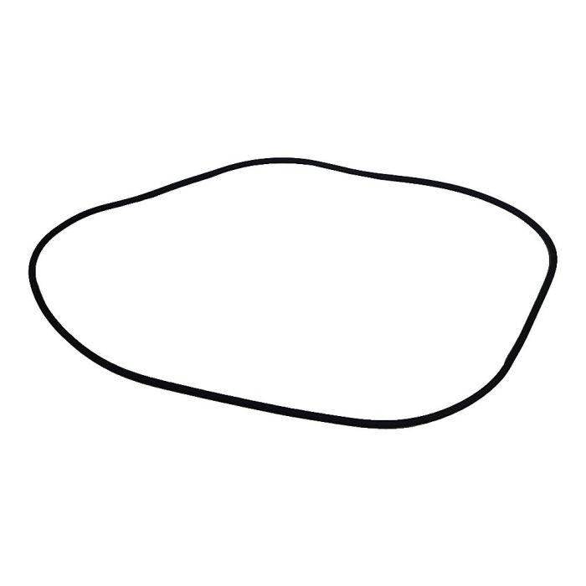
Its two ends or sides may have different curvature or proportions.
$$\boxed{\text{Asymmetric Oval}=\text{Closed}+\text{Smooth}+\text{Unequal Curvature}}$$

9. Organic Oval
# Source: AI Source: Provided by: [Data Path: Persons Table -> ID Column: 1, Name_En Column: Motasem Essam] -> From: [ChatGPT] on [7/25/2026]
An organic oval is a smooth oval-like closed curve with a natural or biological appearance.
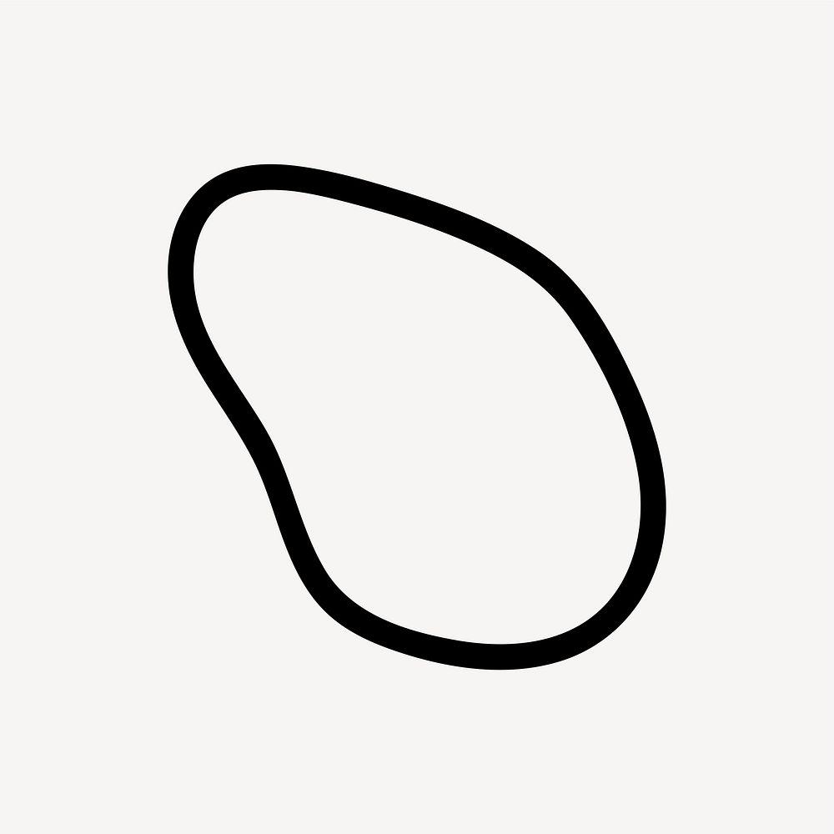
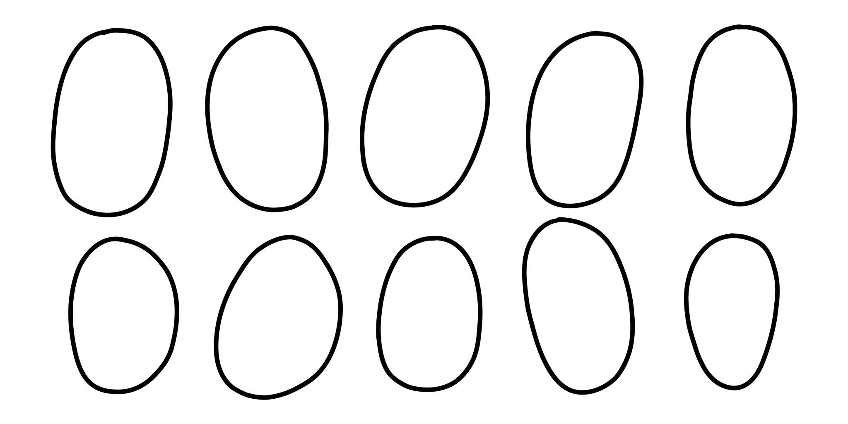
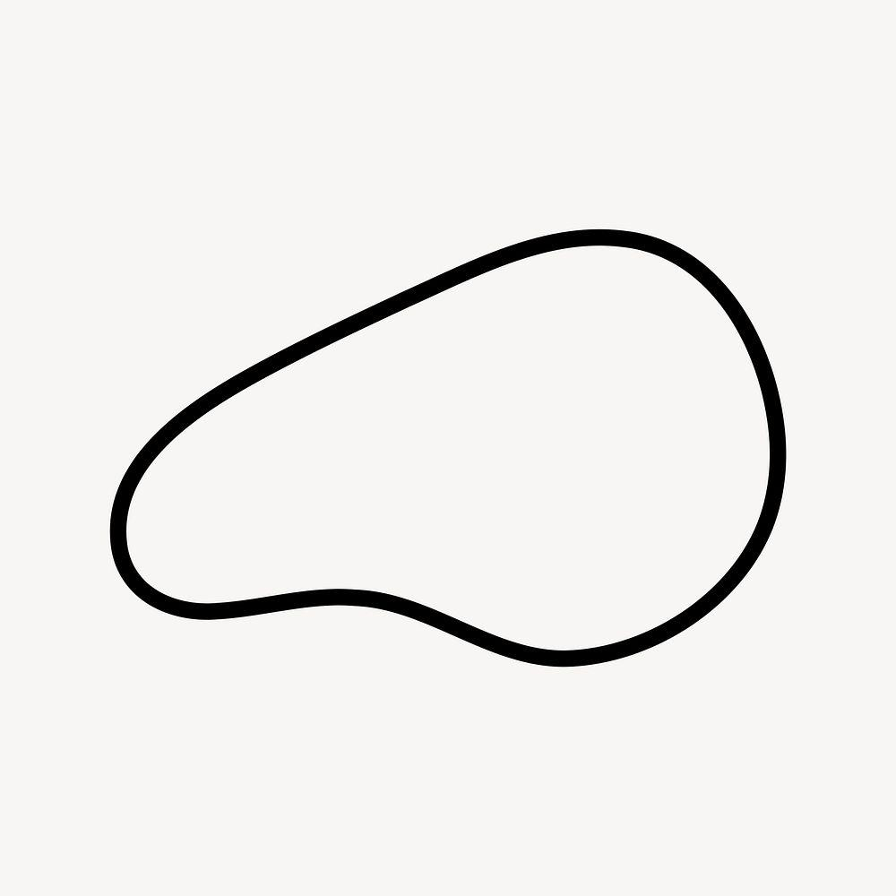
Examples may resemble:
- Seeds
- Stones
- Leaves
- Biological structures
- Natural objects
The term organic describes its appearance rather than a strict mathematical equation.

10. Freeform Oval
# Source: AI Source: Provided by: [Data Path: Persons Table -> ID Column: 1, Name_En Column: Motasem Essam] -> From: [ChatGPT] on [7/25/2026]
A freeform oval is an intentionally designed oval-like closed curve whose curvature is freely controlled.
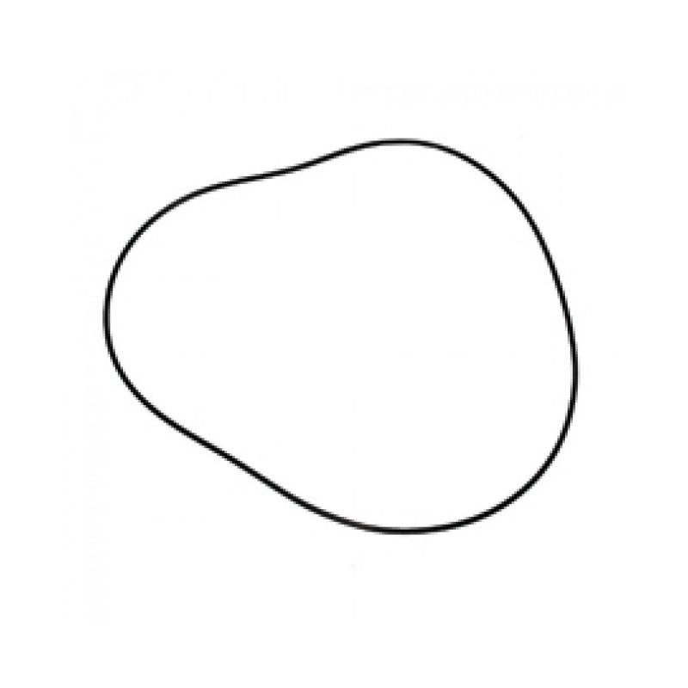
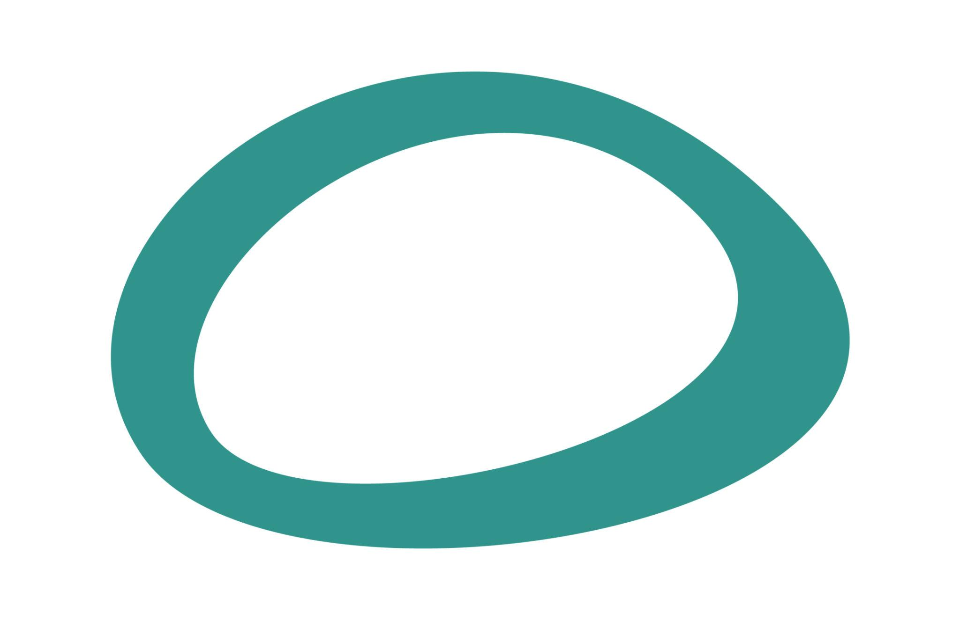
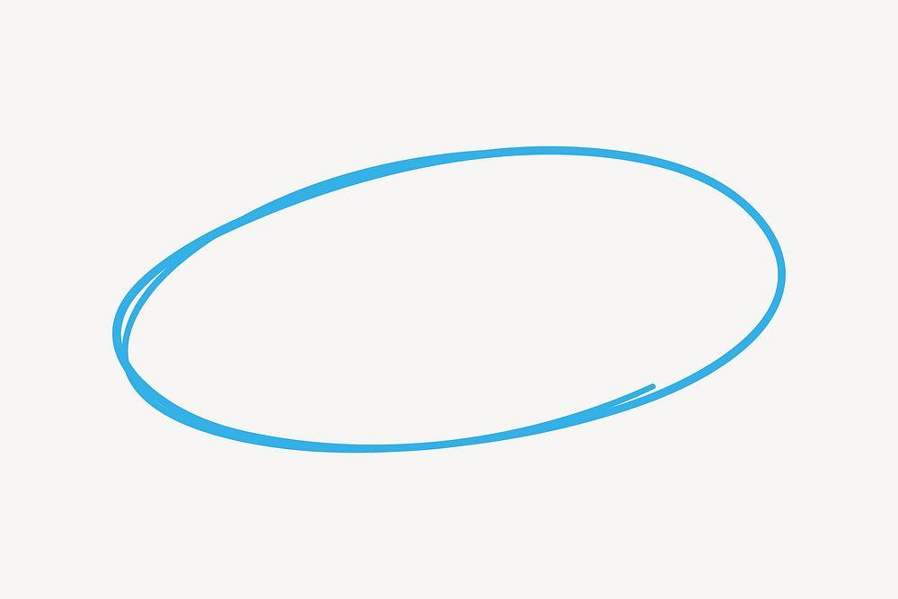
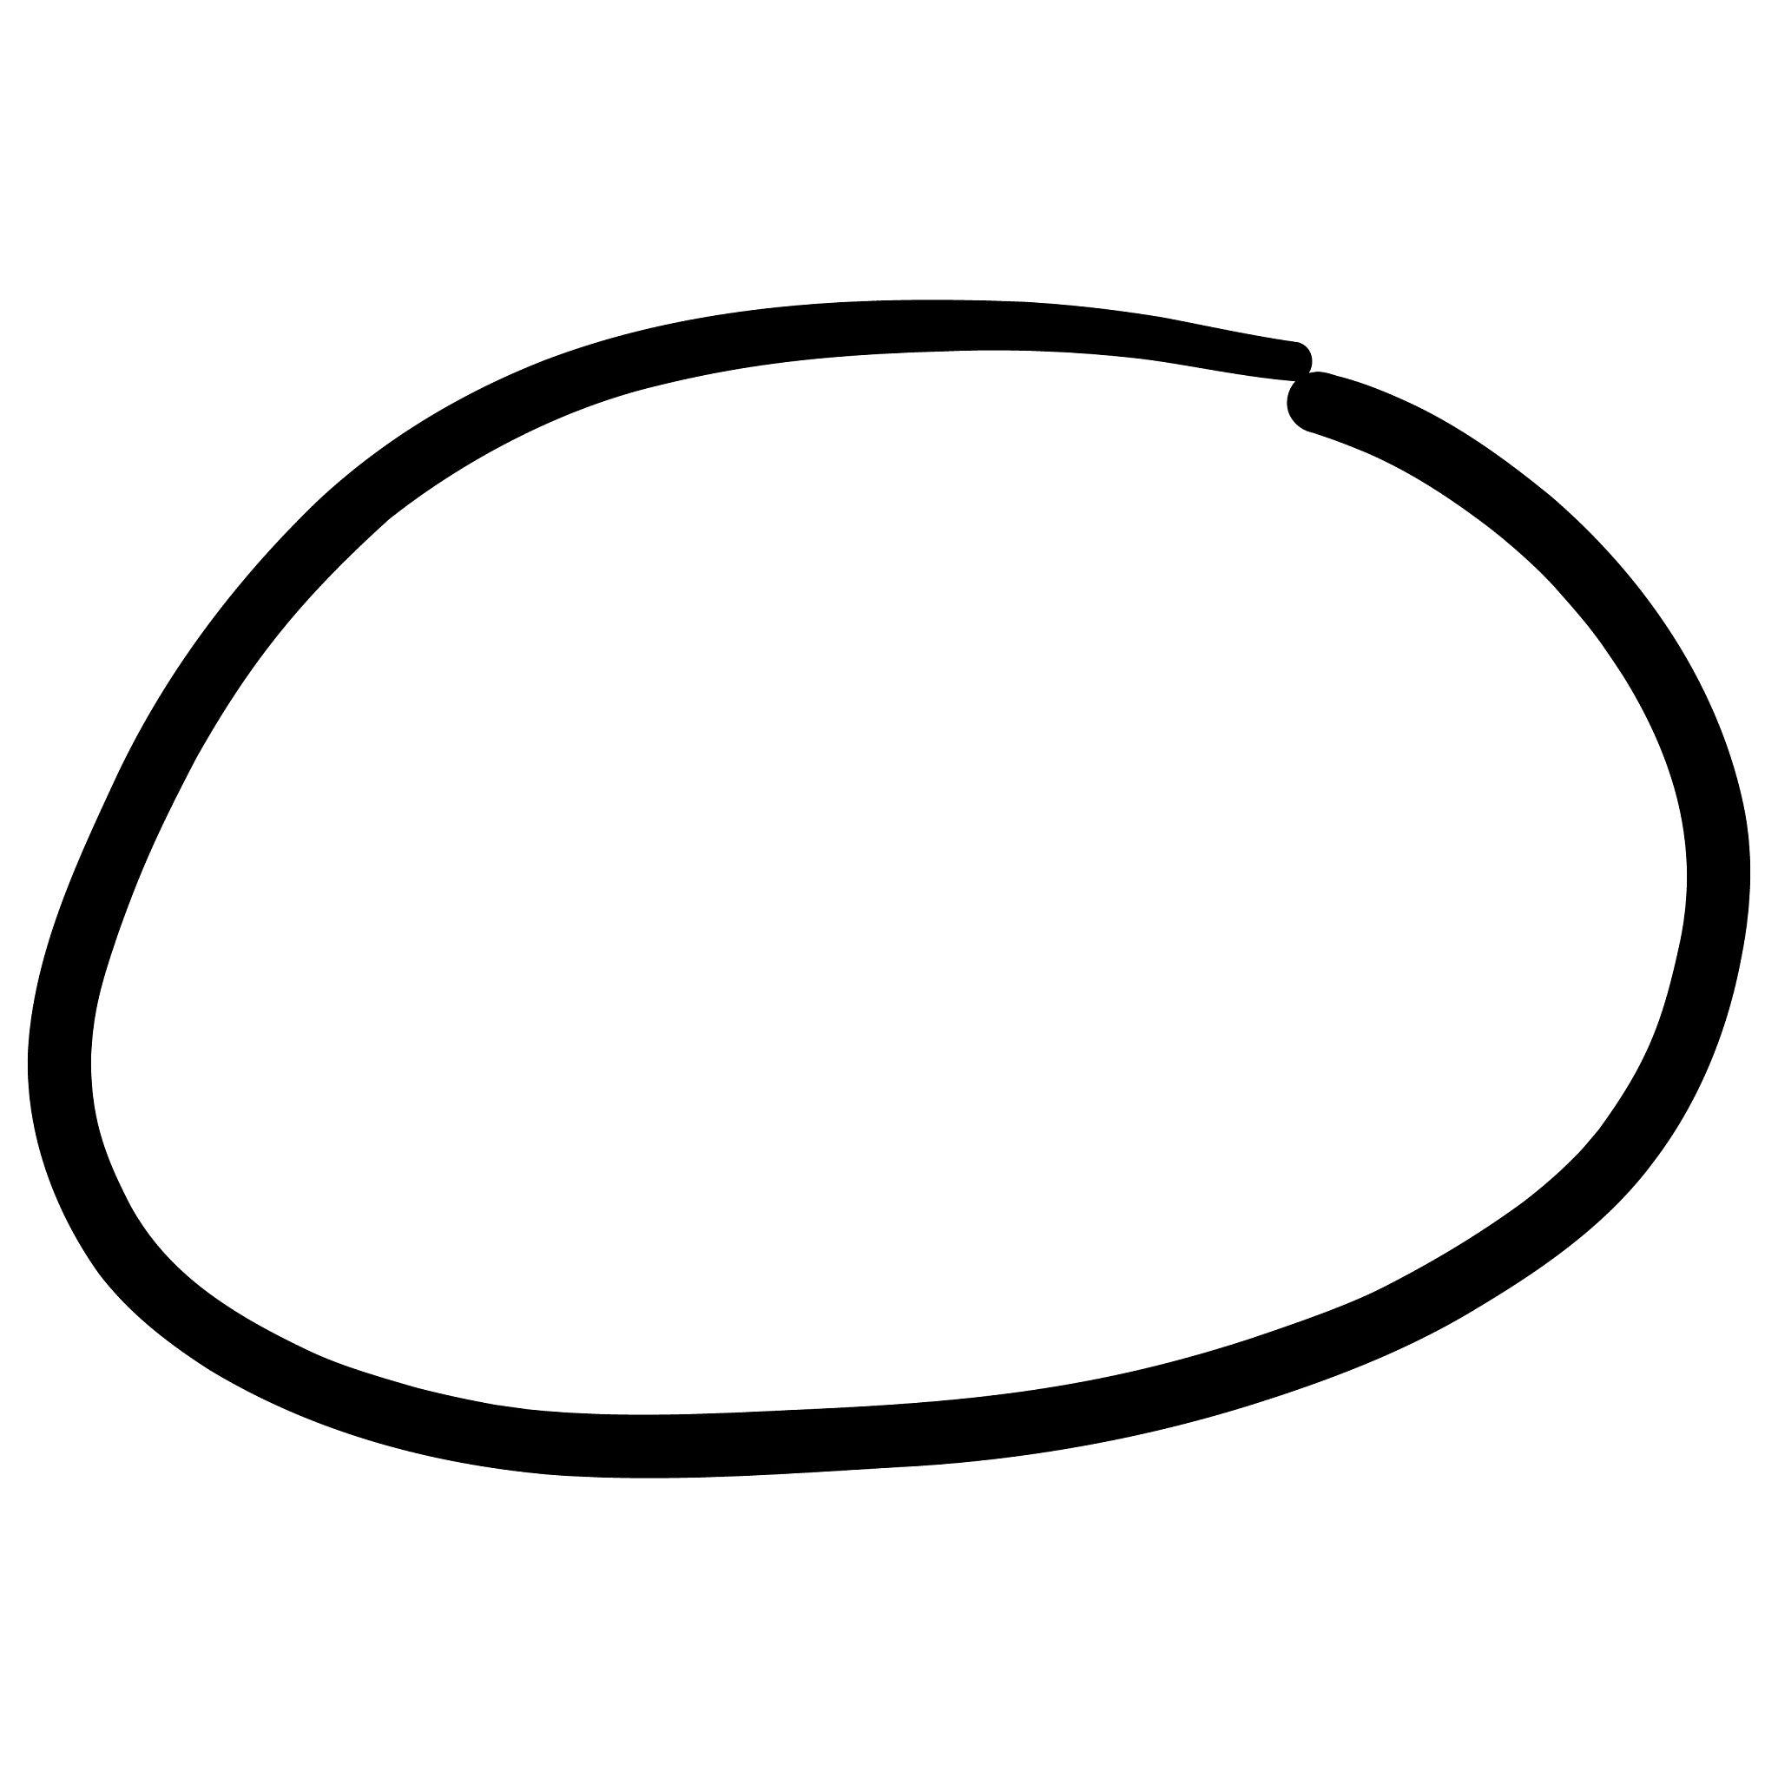
It is common in:
- Graphic design
- CAD
- Product design
- Illustration
- Computer graphics

Oval vs. Ellipse
# Source: AI Source: Provided by: [Data Path: Persons Table -> ID Column: 1, Name_En Column: Motasem Essam] -> From: [ChatGPT] on [7/25/2026]
This distinction is important for your classification system.
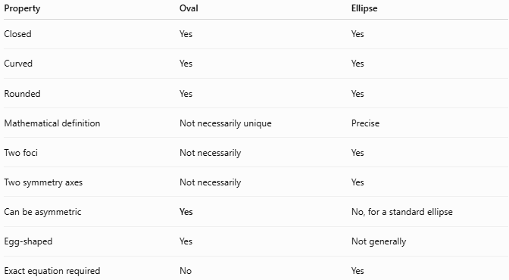
Property | Oval | Ellipse
Closed | Yes | Yes
Curved | Yes | Yes
Rounded | Yes | Yes
Mathematical definition | Not necessarily unique | Precise
Two foci | Not necessarily | Yes
Two symmetry axes | Not necessarily | Yes
Can be asymmetric | Yes | No, for a standard ellipse
Egg-shaped | Yes | Not generally
Exact equation required | No | Yes
Therefore:
$$\boxed{\text{Every ellipse is oval-like}}$$
but:
$$\boxed{\text{Not every oval is an ellipse}}$$

Boundary
# Source: AI Source: Provided by: [Data Path: Persons Table -> ID Column: 1, Name_En Column: Motasem Essam] -> From: [ChatGPT] on [7/25/2026]
An oval closed shape has a continuous curved boundary:
$$\boxed{P_{\text{start}}=P_{\text{end}}}$$
It therefore separates the plane into:
$$\boxed{\text{Interior}+\text{Oval Boundary}+\text{Exterior}}$$

Area
# Source: AI Source: Provided by: [Data Path: Persons Table -> ID Column: 1, Name_En Column: Motasem Essam] -> From: [ChatGPT] on [7/25/2026]
For an elliptical oval, the area can be calculated exactly:
$$\boxed{A=πab}$$
For a general oval, there is no universal area formula because "oval" describes a family of shapes rather than one exact mathematical curve.
The area may instead be determined using:
- Decomposition.
- Coordinate geometry.
- Integration.
- Numerical approximation.
- CAD/GIS measurements.

Perimeter
# Source: AI Source: Provided by: [Data Path: Persons Table -> ID Column: 1, Name_En Column: Motasem Essam] -> From: [ChatGPT] on [7/25/2026]
An oval has a closed curved boundary, so its boundary length can be measured.
For an elliptical oval, the exact perimeter involves an elliptic integral and usually requires approximation.
A commonly used approximation is:
$$\boxed{P≈π\left[3\left(a+b\right)-\sqrt{\left(3a+b\right)\left(a+3b\right)}\right]}$$
where $a$ and $b$ are the semi-major and semi-minor axes.
For a general freeform oval, the perimeter is its curve length.

Classification by Regularity
# Source: AI Source: Provided by: [Data Path: Persons Table -> ID Column: 1, Name_En Column: Motasem Essam] -> From: [ChatGPT] on [7/25/2026]
Your classification can distinguish:
Regular / Standard Oval Shapes
- Elliptical oval
- Symmetric oval
- Horizontal oval
- Vertical oval
Irregular Oval Shapes
- Egg-shaped oval
- Asymmetric oval
- Organic oval
- Freeform oval

Oval Closed vs. Other Closed Curved Shapes
# Source: AI Source: Provided by: [Data Path: Persons Table -> ID Column: 1, Name_En Column: Motasem Essam] -> From: [ChatGPT] on [7/25/2026]
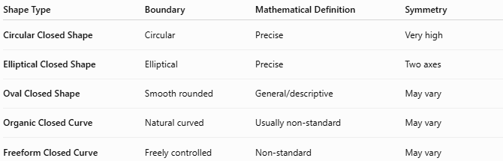
Shape Type | Boundary | Mathematical Definition | Symmetry
Circular Closed Shape | Circular | Precise | Very high
Elliptical Closed Shape | Elliptical | Precise | Two axes
Oval Closed Shape | Smooth rounded | General/descriptive | May vary
Organic Closed Curve | Natural curved | Usually non-standard | May vary
Freeform Closed Curve | Freely controlled | Non-standard | May vary

Key Points
# Source: AI Source: Provided by: [Data Path: Persons Table -> ID Column: 1, Name_En Column: Motasem Essam] -> From: [ChatGPT] on [7/25/2026]
An Oval Closed Shape is:
$$\boxed{\text{Closed}+\text{Smooth}+\text{Rounded}+\text{Generally Elongated}}$$
It:
- Has a continuous closed boundary.
- Has no straight sides in its pure form.
- Has no vertices.
- Encloses a bounded region.
- May be symmetric or asymmetric.
- May be mathematical or freeform.
- May be elliptical, egg-shaped, organic, or custom-designed.

Conclusion
# Source: AI Source: Provided by: [Data Path: Persons Table -> ID Column: 1, Name_En Column: Motasem Essam] -> From: [ChatGPT] on [7/25/2026]
Oval Closed Shapes are smooth, rounded, closed curved forms that are generally elongated or egg-like. Ellipses are a precise mathematical type of oval-like shape, but the term oval is broader and can include elongated, flattened, egg-shaped, asymmetric, organic, and freeform forms that are not exact ellipses. This makes Oval Closed Shapes a useful category between mathematically defined curves such as ellipses and more irregular closed curves such as organic and freeform shapes.

